Western Bat Programmatic Biological Opinion (PBO) and Programmatic Conference Opinion (PCO) for Indiana bat (Myotis sodalis, MYSO), gray bat (M. grisescens, MYGR), northern long-eared bat (M. septentrionalis, MYSE), tricolored bat (Perimyotis subflavus, PESU), and little brown bat (M. lucifugus, MYLU)
link to Programmatic Biological Opinion https://connect.ncdot.gov/resources/Environmental/EAU/BSG/Documents/Bats/Bat%20Programmatic%20(Div%209-14)/WNC%20Bats%20PBO%20Div%209-14%20(2025).pdf

PROCESS FOR USING THE WESTERN BAT PBO:
WHO: ECAP or Division Environmental Staff will enter the project information into the SharePoint site (Environmental Project Manager). You must be a member of this group to submit entries for USFWS review. Contact Cheryl Knepp to be added as a member clknepp@ncdot.gov.
WHAT: Projects that qualify for use include FHWA funded projects or state funded projects with USACE in the lead federal role or if NCDOT is the permittee. If another agency is the lead (TVA for example), which is not a signatory on the PBO (USACE/FHWA), they must provide a written letter delegating NCDOT/FHWA authority to consult with USFWS on their behalf.
WHEN: The notification process will typically begin when the permit drawings are requested so project construction questions can be answered. However, BSG should also be made aware of these projects at the scoping phase to ensure the survey requirement of the PBO is being fulfilled.
**TO QUALIFY FOR PBO USE, PROJECTS MUST HAVE SURVEYS COMPLETED FOR ALL STRUCTURES AT LEAST 2 YEARS IN ADVANCE OF PROJECT LET** To check survey status, see BSG’s online structure survey map here: https://ncdot.maps.arcgis.com/apps/instant/sidebar/index.html?appid=1e3211f382f34406a9077495ebb2719f
WHERE: NCDOT - Environmental Analysis - Project Level Pre Notification Western Bat PBO/PCO
Project Level Pre Notification western bat PBO

Project-Level Pre Notification
For each project conducted under this PBO, the NCDOT designated environmental lead will provide the following information prior to any ground-disturbing actions. The workflow is described below:
- Environmental Project Manager creates a project in IPaC including project boundary and make the following people members: clknepp@ncdot.gov, cdmanley@ncdot.gov, mrmiller2@ncdot.gov, trfox2@ncdot.gov, holland_youngman@fws.gov, mark_endries@fws.gov
- Environmental Project Manager enters the project into the SharePoint site (link above). We have inserted ‘helper text’ under each input field to provide extra guidance and descriptions.
- When the entry is submitted/saved, BSG is notified to conduct a review.
- BSG reviews buffer information, calculations and effect determinations. If all is correctly entered, the project status will be changed to ‘Approved’ by BSG and staff will enter the date in the column ‘Date Submitted to USFWS’. BSG’s role moving forward will be in a support capacity to review calculations and entries but not as the main contact for consultations. Should USFWS have individual project questions, they will contact the person listed under the ‘Submitter’ column.
- USFWS is notified when a project is approved by BSG and completes their pre-notification review of Western Bat PBO projects. Once this step is complete, USFWS will enter information in the columns: ‘USFWS Review Complete’ and ‘USFWS Service Log Number’. In addition to filling in those two columns, USFWS will also still issue a letter acknowledging each project qualifies for PBO use.
- USFWS will approve projects that are pending review on a weekly basis.

Language for Environmental Documents and Commitments:

For NRTR Documentation for projects in Divisions 9-14, we typically do not produce a Biological Conclusion (BC) at this time not knowing what construction activities will occur. It is our protocol to show a BC of Unresolved until we get closer to project permitting and can determine impacts and develop a biological conclusion for listed animal species. The blurb below is appropriate for this stage of project planning.

Biological Conclusion: Unresolved
As of [Date], the following federally protected bat species are listed in IPaC (https://ecos.fws.gov/ipac/) as occurring in the action area: [list of species in IPaC]. Construction activities for this project are unknown at this stage in project planning, NCDOT will resolve Section 7 prior to let as appropriate.

To be included in NEPA Documentation for projects in Divisions 9-14 there will be 2 scenario stages your project could be in, this first paragraph is standard and will be included in both scenarios, however, the second paragraph will differ based on the project stage (red text: further coordinate with BSG to determine project eligibility, starting in 2025, BSG has begun to proactively include the projects’ eligibility for PBO use in the Bat Survey Memos on ETRACS):
The U.S. Fish and Wildlife Service (USFWS), in partnership with the Federal Highway Administration (FHWA), U.S. Army Corps of Engineers (USACE), and NCDOT, has issued a combined Programmatic Biological Opinion (PBO) and Programmatic Conference Opinion (PCO) for the following bat species: Indiana bat (Myotis sodalis, MYSO), gray bat (M. grisescens, MYGR), northern long-eared bat (M. septentrionalis, MYSE), tricolored bat (Perimyotis subflavus, PESU), and little brown bat (M. lucifugus, MYLU).

Scenario Stage 1: If the Biological Conclusion is unknown (red text will change per project):
The proposed biological conclusion for bats is unknown at this stage in project planning and will be rendered prior to let as appropriate. After sufficient design has been completed, the project will be evaluated for potential usage of the PBO/PCO. The PBO/PCO will ensure compliance with Section 7 of the Endangered Species Act for five years (effective through April 1, 2030) for all NCDOT projects with a federal nexus in Divisions 9-14, which includes XXXX County, where TIP is located.

Scenario Stage 2: The BC is known and NCDOT has received the prenotification confirmation letter from USFWS (red text will change per project):
Per current design and construction plans, the project is eligible for PBO/PCO use. This project has been identified within/outside a protective buffer and the biological conclusion for project activities is May Affect, Likely to Adversely Affect. NCDOT can adhere to the appropriate Conservation Measures outlined in the PBO/PCO. The USFWS, Asheville Ecological Services Field Office reviewed this project for coverage under the PBO/PCO issued April 1, 2025. In a letter dated July 7, 2025, USFWS confirmed the project meets the criteria for coverage under this PBO/PCO in accordance with section 7 of the Endangered Species Act of 1973, as amended (16 U.S.C. 1531– 1543) (ESA), thus concluding consultation for the project for Indiana bat, little brown bat, tricolored bat, northern long-eared bat, and gray bat. The PBO will ensure compliance with Section 7 of the Endangered Species Act for five years (effective through April 1, 2030) for all NCDOT projects with a federal nexus in Divisions 9-14, which includes XXXX County, where TIP is located.

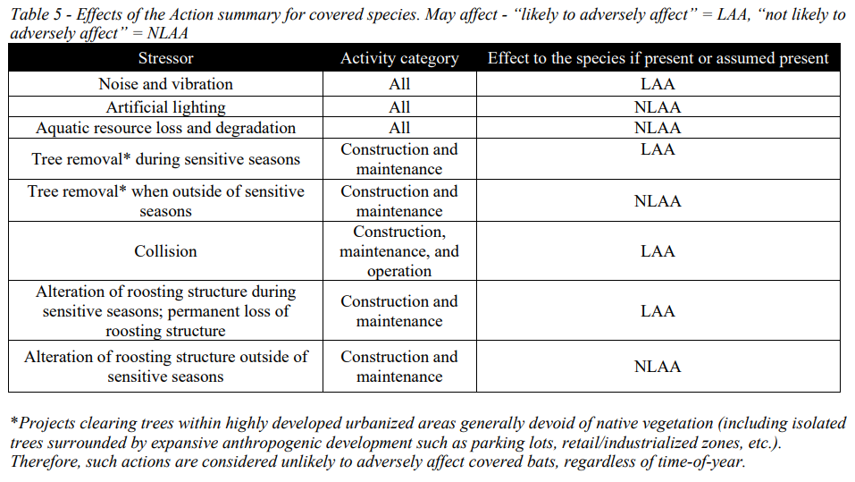

Green Sheet Commitments for projects using western bat programmatic:
In an effort to streamline green sheet commitments and contract language for the projects that utilize the Western North Carolina Bat Programmatic Agreement, the Department will only include certain commitments that involve protected buffers and the reporting requirement. Standard Best Management Practices that are listed as conservation measures in permits will no longer be included in the green sheets or contracts/notes on plans. Please use the following language in contracts to maintain consistency throughout the Department. The first three are only for projects that are in the protected buffered areas, it is very important that people understand not to copy and paste these first 3 for all bat PBO projects. If your project is within a buffered area, enter all of the below, if not, just enter the last two.

If a project is within a protective buffer, as identified by the NCDOT Biological Surveys Group, the following conservation measures shall be adhered to as written in the Western North Carolina Bat Programmatic Agreement (Service log #22-244), and entered as a project commitment as follows:

Title: Tree Cutting Restrictions
Commitment: Limit tree clearing within 100 meters (328 ft) of blue line streams on USGS topographic maps. The following exceptions apply within 10 meters of a stream: (1) the NCDOT must clear easements (utility, drainage, and construction), (2) at bridge sites, the NCDOT must clear the entire width of the right of way beginning at a station three feet beyond the beginning and ending extremity of the structure, per NCDOT Standard Specifications.
Reason: Per Western North Carolina Bat Programmatic Agreement (Service log #22-244)
Commit. Type: One Time
Phase: Construction
Stakeholder: USFWS, BSG
Validation: EAU-ECAP or Division Environmental staff
Fulfillment: Division Office

Title: Percussive Activities
Commitment: To the maximum extent possible, if suitable roost trees or structures are present near high-decibel percussive activities (81-162 dBA as measured from 50 feet from source), those percussive activities will be avoided from May 1 – July 31, when non-volant pups may be present.
Reason: Per Western North Carolina Bat Programmatic Agreement (Service log #22-244)
Commit. Type: One Time
Phase: Construction
Stakeholder: USFWS, BSG
Validation: EAU-ECAP or Division Environmental staff
Fulfillment: Division Office

Title: Permanent Lighting
Commitment: Design permanent lighting systems for an average illumination level of 0.6 footcandle, reducing overall brightness, a 25% minimization from a standard 0.8 fc illumination
Reason: Per Western North Carolina Bat Programmatic Agreement (Service log #22-244)
Commit. Type: One Time
Phase: Construction
Stakeholder: USFWS, BSG
Validation: Roadway Design Unit - Lighting and Electrical Team Lead
Fulfillment: Division Office

If using the PBO (regardless of buffer status), enter in project commitment tracker as follows):

Title: Riparian area restoration
Commitment: Replant riparian areas with native, fast-growing tree and shrub species such as American sycamore (Platanus occidentalis), river birch (Betula nigra), silky dogwood (Cornus amomum), and black willow (Salix nigra) where vegetation has been removed. Riparian plantings will not occur in utility, drainage, and construction easements. If excess property is available outside normal maintenance limits at bridge locations, riparian plantings will be installed where safety requirements allow.
Reason: Per Western North Carolina Bat Programmatic Agreement (Service log #22-244)
Commit. Type: One Time
Phase: Construction
Stakeholder: USFWS, BSG
Validation: Roadside Environmental Unit
Fulfillment: Roadside Environmental Unit

Title: Tree Clearing and/or structure removal reporting
Commitment: For each project involving tree clearing or structure removal, submit final numbers of tree clearing and/or number of structures demolished and the date(s) that these activities actually occurred. This will ensure accurate payments and submittal to USFWS in the required annual report. Numbers must be reported using the link to the PBO Reporting Requirement Form on the Biological Surveys Group (BSG) Connect site here https://forms.cloud.microsoft/g/iiEeEtHFU4.
Reason: Per Western North Carolina Bat Programmatic Agreement (Service log #22-244)
Commit. Type: One Time
Phase: Construction
Stakeholder: USFWS, BSG
Validation: EAU-ECAP or Division Environmental staff
Fulfillment: Division Office

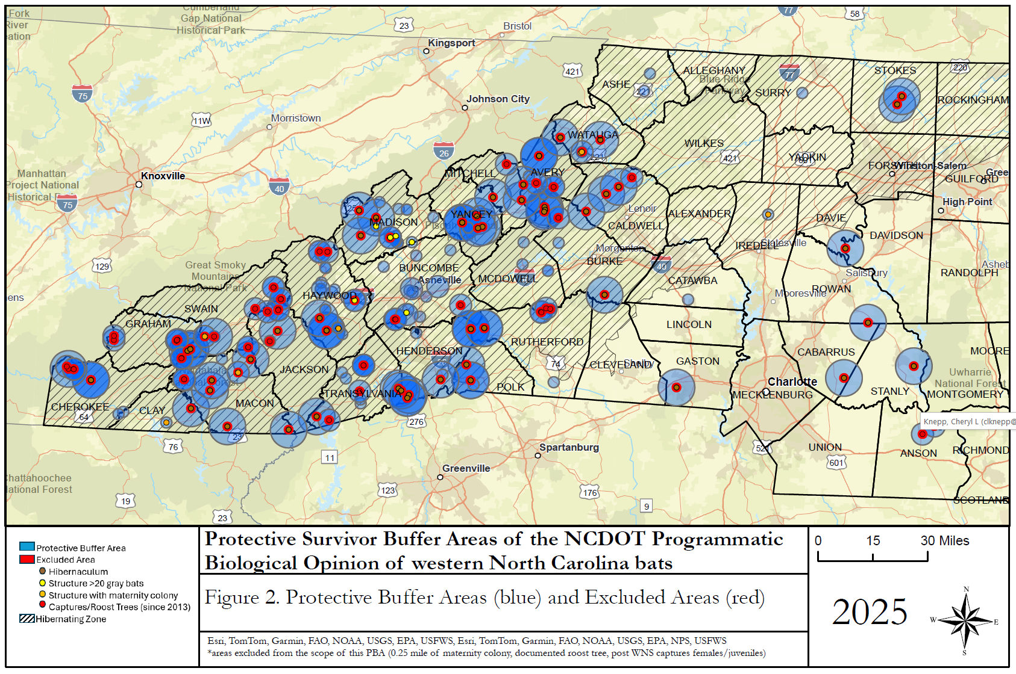
NOTE: For example purposes only, this map will be updated regularly with new bat records, please check with NCDOT BSG

